My Safety Plan

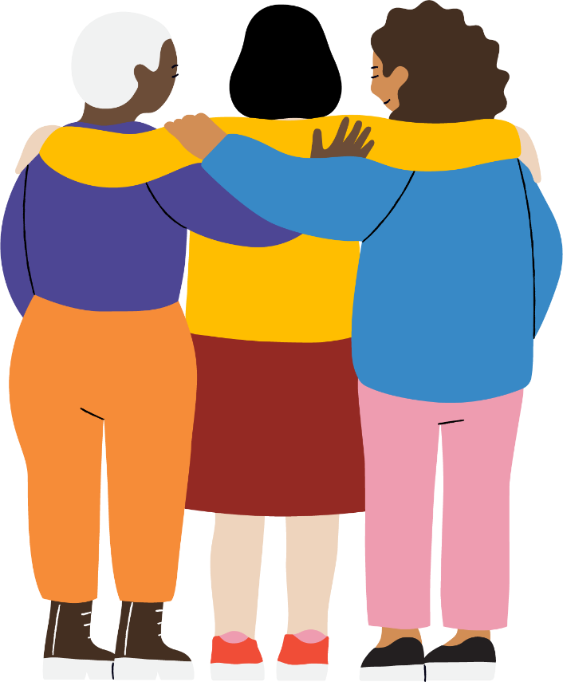

About us
GenWest is an organisation in Naarm/Melbourne’s west working towards gender equity. We help people who are experiencing family violence. We support communities to lead safe and healthy lives, by running social and health education programs. We also work with other organisations and councils to advocate for equal rights and the prevention of family violence.

Contact us
Call us: 1800 436 937
Find us online: genwest.org.au
Email us: info@genwest.org.au
Visit us: 317-319 Barkly Street, Footscray, Naarm/Melbourne, VIC 3011

Acknowledgement
We proudly acknowledge the Aboriginal and Torres Strait Islander communities across Naarm/Melbourne’s west, their rich cultures, diversity, histories and knowledges, and the deep contribution they make to the life of this region.
© GenWest 2023. First printed in April 2010.

If you need an interpreter please call the Telephone Interpreter Service on 13 14 50.

What is family violence?
Family violence is when a partner or family member hurts you or tries to control what you do.
Family violence includes physical things like hitting, pushing, smashing things or locking you inside your house.
Family violence isn’t just physical assault. It can also be:
- Stopping you seeing family or friends
- Pressuring, tricking or forcing you to do sexual things
- Threatening to hurt you, your kids, family members or a pet
- Calling you names or deliberately making you feel bad
- Stopping you having any money
- Constantly checking where you are, what you’re doing and who you’re talking to
These things can hurt you just as much as physical violence.
You and your children, if you have any, have the right to live free from violence and fear.
Trust yourself. You know your situation best. Don’t ignore ‘funny feelings’, if you feel like something isn’t right, or you don’t feel safe, call the police. You could also talk to someone you trust in your family, or a friend.

What is a safety plan?
A safety plan is a guide for staying safe from violence.
Planning for your safety is about looking at what’s happening and deciding what you need to do to help keep yourself safe.
Your safety plan must be about your needs, and it needs to change as your situation changes. A safety plan will include an escape plan as well as things you can do to make your home and your day-to-day activities safer.
A safety plan is about making sure you (and your children if you have any) are safe. It is about taking back control of your life.
Safety plans need to include things you can do to be safe in different places, such as at home, at work, when you are travelling or when you are out with friends. We call these safety strategies.
You will already be doing things to keep yourself safe, and you can include these in your plan. You know your home and your situation best.

Safety at home
Your worker can help you to access funding to pay for things that can make your home safer, like changing locks or installing sensor lights or video cameras.
Here are some things that you can do to make your home safer:
- Install lockable security doors if possible. Keep external doors locked, even when you are home.
- If your keys go missing, change the locks.
- Make sure windows and sliding doors are locked. You can lock doors and windows that slide open cheaply by using a wooden dowel stick so they can’t be slid open from the outside. Your worker can also arrange a locksmith to visit and add a lock or bolt.
My notes
Add your notes.

- Changing locks, or making other changes to a rental property is permitted. You must supply a copy of the key to your real estate agent or the landlord, along with a copy of your Intervention Order that excludes the person using violence from the property. The landlord or agent must not give a copy of the key to the excluded tenant.
- Do not open the door unless you know who it is.
- Install a sensor light at your front door, and put them in the garden if you live in a house.
- Tell friends or neighbours that you trust about what’s happening. Ask them to tell you if they see anyone hanging around outside your home. Tell them to call the police if they are worried about your safety.
- Let friends and neighbours that you trust know if you go away.
- Give contact numbers to people you trust in case of an emergency. This could include a phone number for your children’s school or childcare centre, your work, your parents – anyone who would need to know quickly if something happened to you.
My notes
Add your notes.

- Choose a code word that you can use without attracting attention. For example, if you are on the phone and feel unsafe, tell your friends and family the code word so that if they hear it, they know you aren’t safe and that they need to call the police.
- Make sure everyone in the home talks about strange or unknown phone calls or strange things happening so you all know about it.
- Make an evacuation plan. Make sure everyone in the household who needs to know about it understands what it is. Practice your escape plan.
- Prepare an escape bag and hide it in a safe place or leave it with someone you trust. If you leave, you will need money, keys, clothes, bank cards, driver’s licence, immigration papers, health care or Medicare card, property deeds, medication, birth certificates, passports, and any other important things for you or your children.
- Keep copies of important papers in a safe location.
- Keep electrical fuse boxes locked. Your worker can help you check with your electricity company, as they need to access the box to read a meter. They can supply locks for you.
- Consider installing an alarm that is loud, can be heard outside, and can be set off from inside the house.
My notes
Add your notes.

- Cut back plants and trees around the front of the house and make sure it is well lit at night.
- Is there a ‘safe room’ in your house where your mobile phone works? This could be a toilet or laundry. Make sure it has a good lock. This can be somewhere you and you children can wait for the police to arrive.
- If you have an outside area, keep it free of rakes, shovels, ladders or other tools. Keep shed doors locked.
- If possible/required, lock the area under your house too. Ensure basements are locked.
- If it is hard to talk to your children about what is happening, talk to your worker and ask them for help. They have resources to help and can refer you for children’s counselling.
- Teach your children how to call the police and how to give their full name and address.
- Tell your children’s school or childcare centre about the situation and who has authority to pick up the children. Provide the school or centre with copies of court papers such as Intervention Orders or family law orders.
My notes
Add your notes.

Phone and online safety
We recommend making your safety plan and getting support from a family violence service before making changes to your device or online accounts. Changing your device settings to try and take back control from someone who has been abusive can put you at risk and make you unsafe.
- If you receive abusive or threatening phone calls, messages or emails, report these to the police. This is against the law. Change your phone number if the abuse continues. Your support worker can help you to do this.
- Keep voicemails, text messages, chats or emails that are abusive or threatening. These can be used as evidence of a breach of an Intervention or other order.
- Always check caller ID before answering your phone and don’t answer calls from private numbers or numbers you don’t recognise.
- Be careful about who you give your phone number to. Only give it to people you really trust.
- Turn off all location services on your phone. Phones have privacy, security, location and accessibility settings. It is worth doing an internet search for what settings your phone has, so you can change them quickly later if you need to.
- Set your phone to lock the screen immediately after use.
- Other devices can also put you at risk because they can share your location. These include things like a FitBit or Apple Watch, voice activated devices like Alexa or Siri, cameras and voice recorders and smart home devices like Google Nest.
My notes
Add your notes.

Online safety tips to remember:
- Use a safe device that the person using violence can’t access. This might be a friend’s phone or computer, or a computer at a public library where you can use computers for free. You should use a safe device when searching for support services or anything related to your safety.
- Set up a new email address and use it for all safety planning, such as setting up a new bank account or online banking.
- Be password safe. Change your passwords if it is safe to do so, and use a different secure password for each device (a random series of numbers and letters, not your children’s or pet’s names). Apps like LastPass.com can help you to generate and store multiple secure passwords – you just need to remember one master password.
- Sign out of all your accounts - email, social media and web browsers. Don’t just close the browser or page, click on your account and log out of it.
- Use multi-factor authentication where possible. This is where you receive a code by text to enter before you can log into your accounts.
- Make sure you keep the software on your phone or other device up to date. This can help to make your phone secure.
- Add passcodes, pin numbers or passwords to your devices and set them to lock as soon as you stop using them.
- Use ‘private’ or ‘incognito’ mode when using the internet. You can google how to do this depending on what browser you are using.
- Be careful about what you post on social media. Check all of your privacy settings to ensure you know who is following you and who can see content you post. If you have children who use social media, talk to them about how they can stay safe online. Speak to your friends and family about what they can do to support you to be safe online, for example, by not posting photos of yourself or your children on social media.
If you want to find out more about how to stay safe online, visit the e-safety commissioner’s website: bit.ly/esafetyplanning
Safety apps for your phone or device:
Daisy
Connects you to support services and helps you to be safe.
Sunny
App for women with a disability who have experienced violence or abuse.
Help Me
This app has a warning alarm and can send a message to trusted contacts when you are in danger.
Emergency+
App that helps you to call 000 quickly and allows you to accurately communicate your location.
Positive Pathways
Positive Pathways is made to look like a wellness app. Its main purpose is for use in emergencies with automatic help messages, GPS location and 000 call function.

Car and travel safety
- Keep your car locked even if it is parked in a garage.
- Hide a spare car key somewhere safe, or ask a friend to look after it for you.
- Keep garage doors locked.
- Park in well-lit, busy places when shopping or at work.
- Keep a personal alarm on your key ring and check it regularly to make sure it works. Your family violence support worker can advise you about how these work, and can get one for you.
- Buy a new travel card and don’t register it under your name.

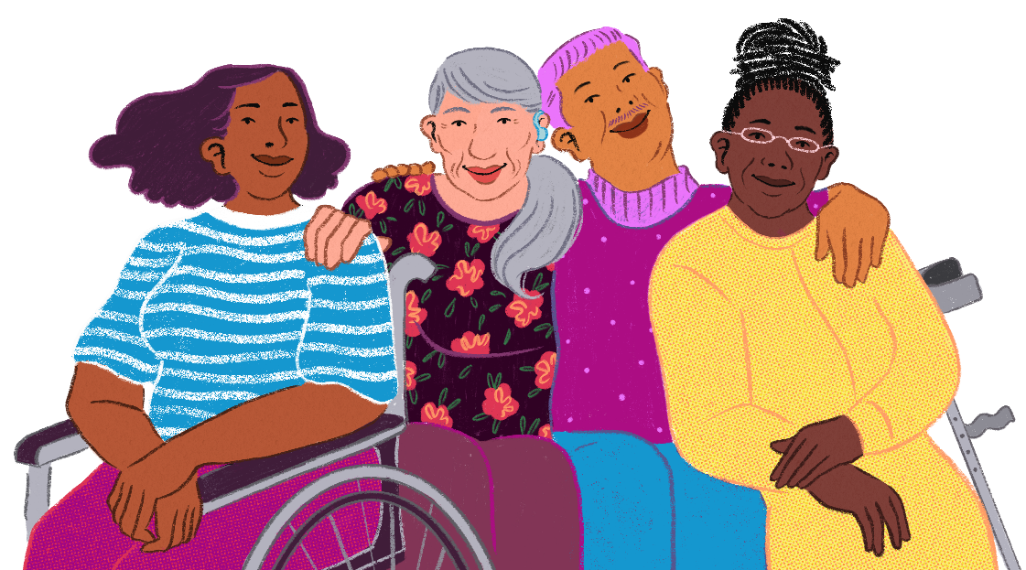

Safety at work and when you are out
My notes
Add your notes.

- It is important that someone at work knows about what’s happening to you. You can tell someone you trust, a manager, or human resources. Some workplaces have paid family violence leave. Ask your human resources department or a manager.
- Park somewhere well-lit and busy when travelling to and from work, and ask a colleague to walk you to your car if it is dark or late.
- Ask a colleague to car share and drive each other to and from work.
- Have a plan about what to do if you are followed home. Know where the closest police station is and drive there if you are in a car and feel unsafe. Plan what you would do if you were followed or harassed on public transport by the person using violence.
- Change your routines. If you have always shopped on the same day at the same place, go on a different day and go somewhere different each time.
- If you feel unsafe when out in public, tell someone – a shopkeeper, café worker or security staff and ask for help. Call 000 in an emergency.

Ways the police can help
- If someone threatens you or you feel unsafe, you can call 000 for police or ambulance help.
- If it’s not an emergency, you can contact your local police station, and the police officers can help you decide what to do: http://www.police.vic.gov.au/location
- You can talk to the police or your support worker about applying for a Family Violence Intervention Order. This can include an Exclusion Order, which can keep the person using violence away from you. You can include your children in the Intervention Order. GenWest has a factsheet about how Intervention Orders work, which you can access at: bit.ly/genwest-ivo
- Make sure you write down or keep a note in your phone whenever the Intervention Order is breached, or whenever you are threatened or made to feel unsafe by the person using violence. Talk to your worker about phone Apps you can use to record these.
- Tell the police if you have an Intervention Order and it has been breached.
My notes
Add your notes.

- If you don’t want to contact the police and you need family violence support, you can contact Safe Steps at any time of the day or night on 1800 015 188.

Other information to help you stay safe
- If you do not already have a family violence support service helping you, you can find your nearest service on the Orange Door website: bit.ly/genwest-TOD.
- In an emergency, call 000 for police and emergency help.
- For help at any time of the day or night, outside usual business hours, call Safe Steps on 1800 015 188.
- Family violence support services can help you to develop your Safety Plan further, and can help you to contact other services, provide financial support and refer you to counselling and help for your children.
- A full list of support services in Melbourne’s west is available at bit.ly/fvserviceswest
Websites with information about what to do if you are experiencing family violence, and would like help:
- www.genwest.org.au
- www.orangedoor.vic.gov.au
- www.safesteps.org.au
- www.1800respect.org.au
- eSafety online safety planning: bit.ly/esafetyplanning

